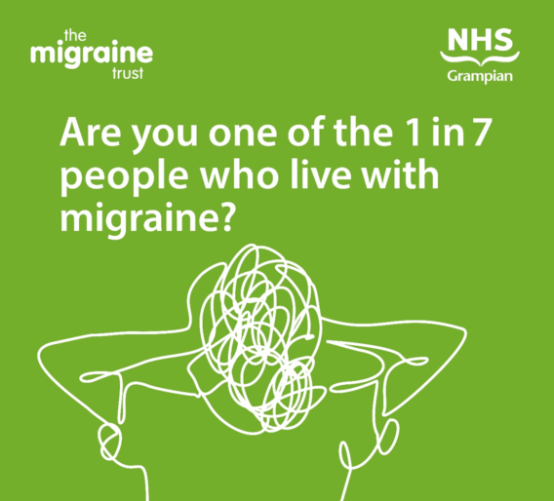

Understanding migraine, treatments and accessing Grampian support

A discussion on why migraine happens, what the current and new treatment options are and how people living in Grampian can access support.

Date: Wed, 31 Jan 2024
Time: 19:00 - 20:30
Venue: Zoom

NHS Grampian in co-operation with The Migraine Trust have worked with pharmacy teams to improve migraine management. In Grampian, people with migraine now have enhanced options for treatment in their local community and better access to self-help resources thanks to fully developed training for pharmacy teams.
- People living with migraine can also access self-help support via nhsgrampian.org/Migraine
As part of the project a webinar has been organised which will bring together a pharmacist, GP and Neurology Consultant to discuss why migraine happens, what the current and new treatment options are and how people living with migraine in Grampian can access support.
- If you would like to attend the webinar please register for a ticket here:
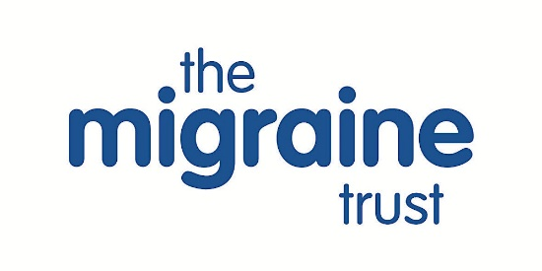 | Understanding migraine, treatments and accessing Grampian support.  A discussion on why migraine happens, what the current and new treatment options are and how people living in Grampian can access support.  www.eventbrite.co.uk

